**1.Calendar**

A calendar is a system of organizing days for social, religious, commercial or administrative purposes. This is done by giving names to periods of time, typically days, weeks, months and years. A date is the designation of a single, specific day within such a system. A calendar is also a physical record (often paper) of such a system. A calendar can also mean a list of planned events, such as a court calendar or a partly or fully chronological list of documents, such as a calendar of wills.

The primary practical use of a calendar is to identify days: to be informed about or to agree on a future event and to record an event that has happened.

Calendars are also used to help people manage their personal schedules, time and activities, particularly when individuals have numerous work, school, and family commitments. People frequently use multiple systems, and may keep both a business and family calendar to help prevent them from overcommitting their time.

**1) Schedule events**

In Calendar, it’s easy to schedule one-time activities, such as conferences, as well as recurring events, such as staff meetings. When you receive an invitation to an event, you can let everyone know if you’re attending with a single click.

In this section, you learn how to:

1.1 Create an event

1.2 Invite guests

1.3 Reserve a room and resources

1.4 Add event details, video conferencing, and attachments

1.5 Save and update events

1.6 Respond to events

1.7 Check guest attendance

1.8 Delete and restore events

**2) Create reminders**

To remember something on your to-do list, add a personal reminder.

In this section, you learn how to:

2.1 View reminders

2.2 Create a personal reminder

2.3 Change a personal reminder

2.4 Complete or remove a personal reminder

**3) Share and view calendars**

Share your calendar with co-workers, family, and friends so they can easily see when you’re available. You can look at other people’s calendars to do the same.

In this section, you learn how to:

3.1 Share your calendar

3.2 View other people's calendars

3.3 Create a shared calendar

3.4 Import and export events and calendars

3.5 Delete a calendar

3.6 Add out-of-office dates to your calendar

**4) Customize your calendar**

Now that you know how to use all the key features in Calendar, you can customize it further to match the way you work.

In this section, you learn how to:

4.1 Manage event notifications

4.2 Choose your calendar view

4.3 Change your calendar's look

**5) Access your notes and tasks**

Keep track of your notes and tasks without leaving Calendar.

In this section, you learn how to:

5.1 Open notes in Google Keep

5.2 Open your to-do lists in Google Tasks

5.3 Get add-ons

**2. To Do list**

Time management is the process of planning and exercising conscious control of time spent on specific activities, especially to increase effectiveness, efficiency, and productivity. It involves a juggling act of various demands upon a person relating to work, social life, family, hobbies, personal interests and commitments with the finiteness of time.

A time management system is a designed combination of processes, tools, techniques, and methods. Time management is usually a necessity in any project development as it determines the project completion time and scope. It is also important to understand that both technical and structural differences in time management exist due to variations in cultural concepts of time.

Project management: Time management can be considered to be a project management subset and is more commonly known as project planning and project scheduling. Time management has also been identified as one of the core functions identified in project management.

Organizational time management is the science of identifying, valuing and reducing time cost wastage within organizations. It identifies reports and financially values sustainable time, wasted time and effective time within an organization and develops the business case to convert wasted time into productive time through the funding of products, services, projects or initiatives at a positive return on investment.

Your phone has a to-do list app. You computer has a to do list. But it’s *how* that to-do list works with other apps you use that is key. For example, does your [project task management software](https://www.projectmanager.com/software/task-management) at work come with a personal to-do list? Are you able to import your to-do lists as tasks for you or your team, or are you always juggling multiple lists in multiple places?

You can streamline all those lists! We’ve outlined 3 key features you should look for when shopping for your next to-do list app:

**Essential Features for Your To-do list**

You might have a [method for managing your own to-do list](https://www.projectmanager.com/blog/managing-your-task-list), but if you’re a busy professional than that’s just the first step in your day. Even if you use one of the aforementioned one-off apps, your digital pocket is going to get cramped. Wouldn’t it be great to have everything in one place?

Of course it would, and it can. If you have an online project management software, your to-do list is now incorporated into your everyday work life. That creates a seamless, easy and more efficient way to stay on top of *all*your tasks.

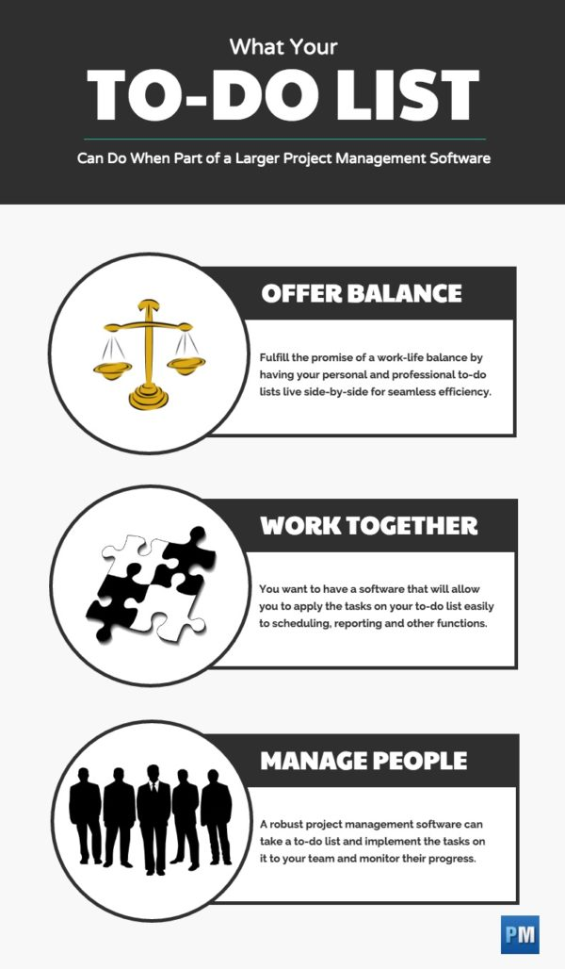

When you’re shopping for a to-do list app why not first see if it has these three features. If it doesn’t, you probably don’t want it. Then take a look at your project management software. Does it have these tools? It better, or it’s time to upgrade.

**1. Supports Work-Life Balance**

There’s a lot of talk about the importance of not having work monopolize all your time, but leaving yourself a personal life. A happy worker is a productive worker. It’s said that a project leader should work to [make their team happy](https://www.projectmanager.com/blog/is-it-your-job-to-make-your-team-happy).

One way to do that is by giving them the tools to manage both their work tasks and their home tasks. It’s unrealistic and not even good business to expect a team member to on the clock every second their in the office. They need breaks, time to make personal phone calls, even steep out into the daylight and maybe get a bite to eat or buy something nice.

Therefore, with a project management software that has a to-do list with privacy settings you and your team can stay on the same page and the doctor’s appointment or your kid’s school presentation are only a click away.

**2. Integrates with Other Tools**

Your personal to-do list may also be important to your work to-do list. Let’s say a team member is not going to be available one day because of that doctor’s appointment. You need to know that in order to have someone else take over the absentee member’s tasks or make sure their absence isn’t blocking the progress of the project.

By having a to-do list that can be integrated into your software, you can prepare for these temporary disruptions and act accordingly. Your team member should be able to access the software anywhere and at anytime because it’s online. Then with the collaborative features notify you about their appointment.

With the integrated software it’s easy to then adjust your project tasks, move around the necessary files and even mark the dark on the shared calendar so the information is quickly and simply disseminated among your team. A simple to-do list can’t do this. By incorporating your to-do list into a more robust project management software you’ve just removed several unnecessary steps.

**3. Managing Teams**

To-do lists are really just a smaller task list. With the to-do list being a part of a larger suite of software tools you can apply your to-do list to the product without having to make the process more complicated than it needs to be.

Having everything under one roof, so to speak, means that you can combine different tasks you’ve assigned to your team and items on your to do list that relate to those specific tasks into the various parts of your project management software, whether that be in your schedule or your reports or your files. It’s all there, moved as easily as a keystroke.

Having to-do lists seamlessly part of your larger project management software makes inviting people a breeze, as well. You can send them invites, give them full or partial access to the software and start assigning them tasks or sending them reports. It’s a great way to manage your team and even your stakeholders.

**Be More Productive and Efficient**

A to-do list is a great tool, too great not to have it adaptable to your larger project management software. By having a to-do list that reaches into every aspect of your work you are more efficient and productive. That means less time doing busy work, and more time meeting deadlines within your budget.

*If you’re looking for an integrated software suite that includes a to-do list and all the other bells and whistles you use daily when leading a project, then try*[*ProjectManager.com*](https://www.projectmanager.com/)*. The online collaborative tool is crafted for project managers and offers real-time dashboard views of the progress of your project. Take a 30-day free trial and see for yourself.*

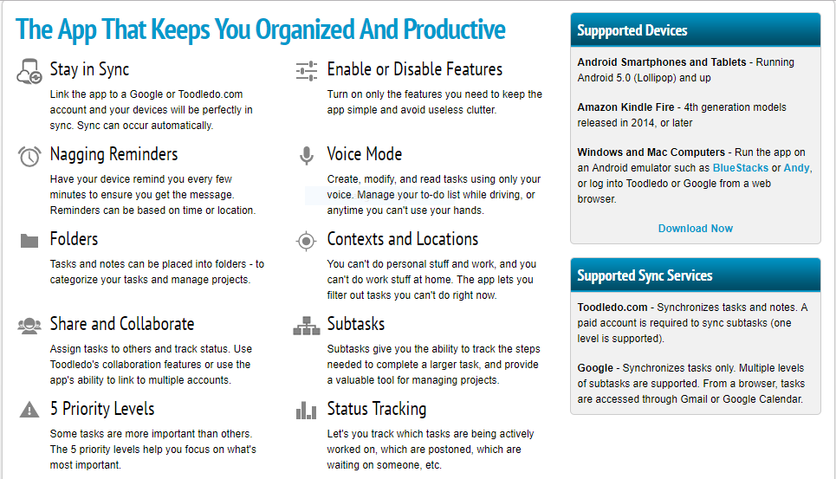

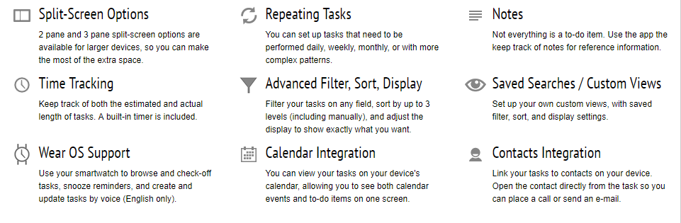

3. Location

That helps people to share his location with them and shared event location meeting with customers.

Much has changed over the last half-decade, but we’re not going to focus on it all. Instead, we’re talking location, and more specific, social networks utilizing location-based features in a meaningful way– here and now. Following are 10 features that are trending up (way up) in the location-based app world:

**1) Using the map as an interface instead of a news feed**

News feeds are inherently passive and becoming dated. When one makes location a principal component of status updates, photos, or other content, this provides users more context as to what’s occurring in real-time. Folks can follow brands, people and trends with location-based updates thus transforming the map into a real-time interface.

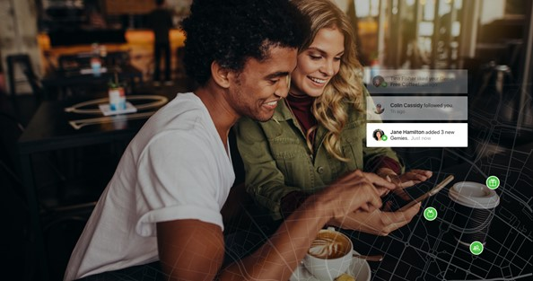

**2) Notifications, on the spot, when one needs them**

Apps can communicate helpful push notifications surrounding deals of the day, dangerous situations, or simply timely info about upcoming events in your local community. No more scrolling to find information, as once it’s tagged in a location-based platform, the user is notified on the spot. Just when you need it.

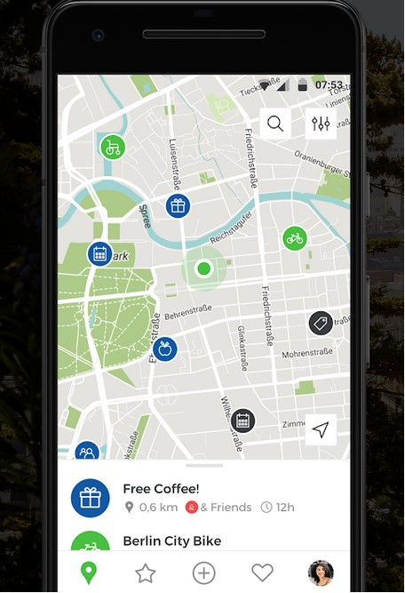

**3) Be your own news editor or micro-blogger**

Choose what type of information you want to be notified about (no more spamming), and you are in charge (not the platform) by following a person, brand, organization or company. Moreover, you can simply filter away information that’s not relevant to you

**4) The Equal Community**

Citizen, organization, business or municipality, they’re all part of the local community and thus equally privy to timely information (messages, ads, etc.). As the concept of the sharing economy becomes more prevalent everyone will operate freely to inform/promote their goods, services, or relevant information in said local community.

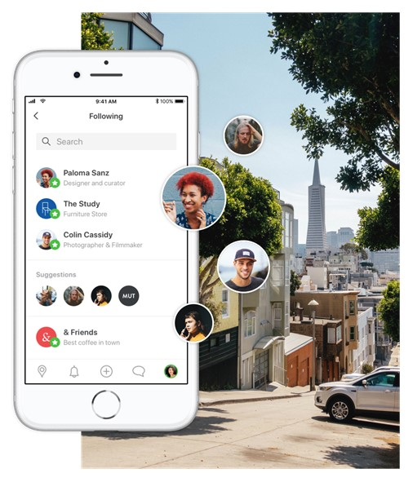

**5) Suggestions**

This is cool as once the location-based app gets to know you a bit better, the suggestions it spits out will be based on your profile, interests and who you follow.

**6) Rewards Programs**

In the (near) future, a user operating on a location-based platform will be granted access to location-based rewards programs providing deals and points just by walking into a local business.

**7) Location-based augmented reality**

Augmented reality in conjunction with GPS, location sensors and geospatial data techniques will transform the way we connect and move through our real, physical space. Sharing data, pictures and other content on a location-based platform will be flat out mind-blowing.

**8) Location intelligence and open data**

On the business end, utilizing location intelligence for example to evaluate new growth opportunities for a real estate investor, or crossing demographic data with credit card transactions to determine how banks can capitalize on new lending products successfully leverages open data and location to stimulate economic growth.

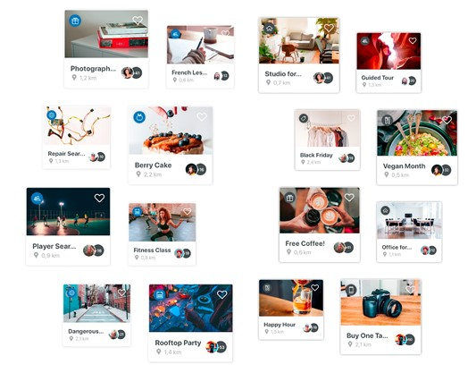

**9) Location data is no longer limited to specialists**

Once the job of highly trained specialists, nowadays a city’s municipality staff can alongside their data analysts take a pulse of the city and make transit and emergency service decisions based on real-time data from hundreds of calls and other location-based sources.

**10) Increased democratization of data**

As a community, we will embrace this shift and work together to create an environment where we democratize the access and analysis of data, rather than placing the power within a small group of individuals or companies. Location is critical for this.

**4. Alarm clock**

That use to predict the user to a meeting or important event to remember to do it also shared this event with the friends.

## The important features:

1.     Keeping Business Assets Safe

2.     Safe Cash Flow

3.     Safe Working Environment

4.     Added Protection

5.     Focusing on Important Things

6. Real-Time Security Updates

7. Focus on What Matters the Most

8. A Smart Decision

**5. Weather**

Weather is something all humans in the world constantly experience through their senses, at least while being outside. There are socially and scientifically constructed understandings of what weather is, what makes it change, the effect it has on humans in different situations, etc. Therefore, weather is something people often communicate about.

There are several reasons why weather forecasts are important. They would certainly be missed if they were not there. It is a product of science that impacts the lives of many people. The following is a list of various reasons why weather forecasts are important:  
  
1. Helps people prepare for how to dress (i.e. warm weather, cold weather, windy weather, rainy weather)  
2. Helps businesses and people plan for power production and how much power to use (i.e. power companies, where to set thermostat)  
3. Helps people prepare if they need to take extra gear to prepare for the weather (i.e. umbrella, rain coat, sun screen)  
4. Helps people plan outdoor activities (i.e. to see if rain/storms/cold weather will impact outdoor event)  
5. Helps curious people to know what sort of weather can be expected (i.e. a snow on the way, severe storms)  
6. Helps businesses plan for transportation hazards that can result from the weather (i.e. fog, snow, ice, storms, clouds as it relates to driving and flying for example)  
7. Helps people with health related issues to plan the day (i.e. allergies, asthma, heat stress)  
8. Helps businesses and people plan for severe weather and other weather hazards (lightning, hail, tornadoes, hurricanes, ice storms)  
9. Helps farmers and gardeners plan for crop irrigation and protection (irrigation scheduling, freeze protection)  
10. Helps people involved with certain activities to know if conditions will be good (i.e. skiing, boating, ballooning)  
11. Helps people know outside weather dangers (i.e. heat index, wind chill, severe weather)  
12. Helps people plan for when to do certain activities that are influenced by weather (i.e. fertilizing, bug spraying, gardening)  
13. Helps people know if they need to leave early for work  
14. Make an uncertain future a little more certain (i.e. knowing changes that will occur in weather)

**6. Email address**

For one thing, you need to consider the fact that business emails are a great way of communicating with clients and potential customers all over the world. Sometimes phone calls are not a viable form of communication due to language barriers and time zones. But emails allow you to connect with people across the world in a professional and concise fashion. Of course, you need to make sure the emails you’re sending are of the highest quality they can possibly be, and that might mean a bit of work and hiring people to craft emails for you.

## The important features:

## 1) Faster Communication

Email is a faster means of communication and correspondence. With email, business people are not held up by delays commonly experienced when sending correspondence in the mail.

## 

## 2) More Accessibility

Email eliminates time and global barriers. When business people use email they can send and receive information at any hour, day or night. Since email is Internet-based, advanced communication technology makes it possible for individuals to access email from anywhere in the world, via an Internet connection from their computers, cell phones or personal digital assistants. This allows business people who travel for work to stay connected wherever they are.

## 3) Shrinking Your World

Email reduces geographic and time zone barriers for businesses.

4) Efficiency and Productivity

Email can help increase productivity. Business owners can communicate with established distribution lists, automatically forward information based on a topic, or send information to specific individuals as needed.

5) Penny-Pinching Economy

Moving communications from physical mail to email can result in significant savings in postage costs, shipping supplies and employee resources. Businesses can also decrease customer service support costs by focusing on email customer support options rather than phone-based services.

6) Used by Almost Everyone

In past decades, when email was new, businesses caught on quickly to its utility, speed and low cost. Today, email is a nearly ubiquitous service; almost everyone has at least one email account, making it a must-have for modern business communications.

Proposed Solution

**Our app is a personal organizer for time, event and meeting .That helps people to planning the future work and remember them for busy time. this app send notification to the user to predict them the time working, Also partition the time .As well help business men preparation their plan in this company. Our app does this with fairly easy-to-use intranet and extranet tools include:-**

* **Flexible Structure**

Organize the time of the user by many models such as (To do list –

Calendar – Notebook).

* **Various Features**

Contains all the features that needed to communicate with the user efficiently in a formal way (Create events- Create meeting- Forms-Tasks)

* **Effective Communication**

Send notification for user.

Remember the user the busy time.

Predictthe user through the alarm clock.

* **Time Management**

Schedule (meeting –events).

Tasks (to do-doing-done)

**Comparison:**

|  |  |
| --- | --- |
| Applications that perform a lot of same functions:- - when we search for applications that performed the same purpose,  we found (google assistant , cortana and Robin) but it has a lot of disadvantage that illustrate it  1. outlook is very complex , not comfortable  2. it need to training to use it well  3. not friendly user interface , we can add application for google assistant development to use it easily.  4. outlook is not free , the cost of package was several dollars , Because of part of google developers  5. platform outlook is to run on operating system and google services | |
|  | |
|  | |
|  | |
|  | |
|  | |
|  | |
|  | |
|  | |
|  | |
|  | |
|  | |
|  | |
|  | |
|  | |
|  | |
|  | |
|  | |
|  |
|  |
|  |
|  |
|  |
|  |
|  |

Difference between my application and outlook:-

1. My app is very simple and quickly

2. It is free and can improve features of application

3. Platform is an IOS and Android mobile application that can download from google play or app store

4. We can use it manually or voice

5. Daily organizer organization list every day.